Homework #1
POSC 3410 - Quantitative Methods in Political Science
The Student’s Name

1. Get the mean of the percentage of the vote Trump got in the primary. Get the median. What does this suggest in terms of skew of the variable?
Lorem ipsum dolor sit amet, consectetur adipiscing elit. Cras aliquet est sapien, at mollis sapien sollicitudin in. Duis vel maximus tellus. The mean is 36.13. The median is 35.55. The difference between the two is 0.58, which is not a lot.
2. Get a density plot of the Trump share variable. What does this suggest about the distribution of this variable?
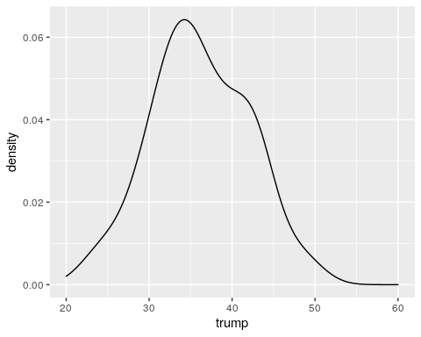
Nullam odio nibh, finibus et nibh in, pulvinar hendrerit est. Phasellus euismod varius erat in euismod. Vivamus id ipsum vulputate, rhoncus lectus ut, luctus orci.
3. Look at the mean of the population variable and then look at the median. Get a density plot too. What does this suggest in terms of skew of the variable?
Sed consectetur sem quis massa facilisis, et sodales ligula aliquet. Praesent nec dui varius nulla ultricies molestie. The mean is 1.050539610^{5} while the median is 5.8398510^{4}. Here’s the density plot you wanted.
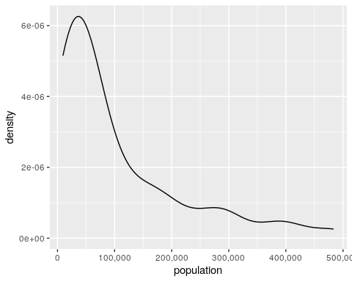
4. Why do you think the population variable has this distribution?
Suspendisse lacinia quis leo sit amet ullamcorper. Vestibulum ante ipsum primis in faucibus orci luctus et ultrices posuere cubilia Curae.
5. Take a natural logarithm of the population variable and then get the mean and median again. Get a density plot too. What do you see?
The mean is 11.019 and the median is 10.974.
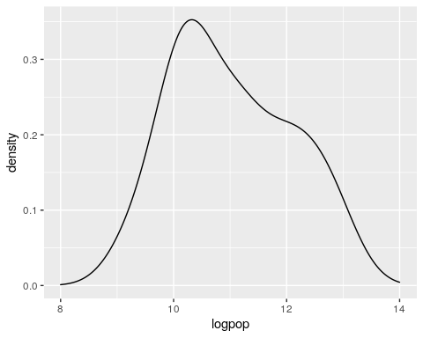

Extra Credit
6. Run the regression that seeks a minimal model to explain the county-level vote share for Trump in the Republican primary. What do you think these results suggest? Be mindful of ecological fallacies.
##
## Call:
## lm(formula = trump ~ illiteracy + unemployment + perblack, data = SCP16)
##
## Residuals:
## Min 1Q Median 3Q Max
## -7.626 -2.388 0.348 1.612 10.446
##
## Coefficients:
## Estimate Std. Error t value Pr(>|t|)
## (Intercept) 12.31072 2.70773 4.547 4.57e-05 ***
## illiteracy 0.81136 0.18401 4.409 7.06e-05 ***
## unemployment 2.50525 0.50059 5.005 1.05e-05 ***
## perblack -0.20685 0.06187 -3.343 0.00175 **
## ---
## Signif. codes: 0 '***' 0.001 '**' 0.01 '*' 0.05 '.' 0.1 ' ' 1
##
## Residual standard error: 3.481 on 42 degrees of freedom
## Multiple R-squared: 0.6658, Adjusted R-squared: 0.6419
## F-statistic: 27.89 on 3 and 42 DF, p-value: 4.392e-10

